
DEPARTMENT OF COMPUTER SCIENCE

BSCS 4th B

COURSE: COMPUTER ORGANIZATION AND ASSEMBLY LANGUAGE (CS – 221 L)

SUBMITTED TO: MA’AM SABA LATIF

SUBMITTED BY: SAADI SAFDAR

REGISTRATION NO: UW-24-CS-BS-088

LAB ASSIGNMENT: 2

Lab Tasks:
1. Write a MIPS program to subtract and multiply two numbers and print all
results.

.data
val1: .word 20
val2: .word 5
msgSub: .asciiz "Subtraction Result: "
msgMul: .asciiz "\nMultiplication Result: "

.text
main:
lw $t0, val1
lw $t1, val2
sub $t2, $t0, $t1 # Subtract
mul $t3, $t0, $t1 # Multiply

li $v0, 4 # Print Label
la $a0, msgSub
syscall
li $v0, 1 # Print Sub Result
move $a0, $t2
syscall

li $v0, 4 # Print Label
la $a0, msgMul
syscall
li $v0, 1 # Print Mul Result
move $a0, $t3
syscall

li $v0, 10 # Exit
syscall

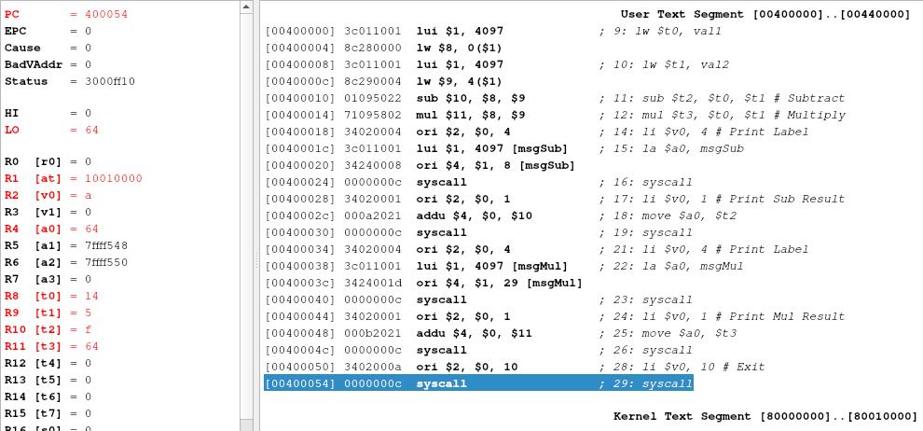

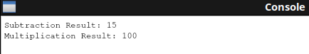

2. Write a program to calculate the factorial of a number entered by the user.
Example: Input 5 → Output 120

.data
prompt: .asciiz "Enter a number for Factorial: "
result: .asciiz "Factorial is: "

.text
main:
li $v0, 4 # Prompt user
la $a0, prompt
syscall
li $v0, 5 # Read integer
syscall
move $t0, $v0 # n = input

li $t1, 1 # product = 1
loop:
blez $t0, end_fact # if n <= 0, exit loop
mul $t1, $t1, $t0 # product = product * n
addi $t0, $t0, -1 # n = n - 1
j loop

end_fact:
li $v0, 4 # Print Label
la $a0, result
syscall
li $v0, 1 # Print Result
move $a0, $t1
syscall

li $v0, 10
syscall

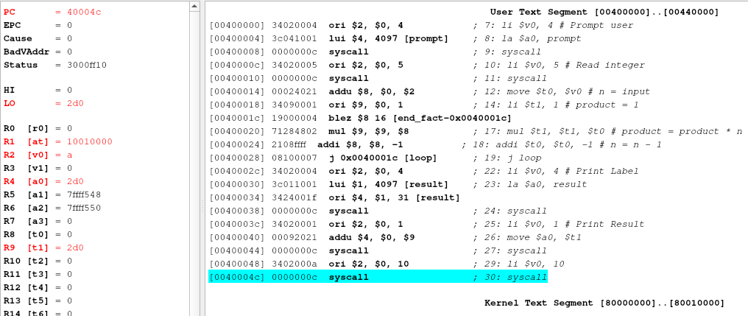
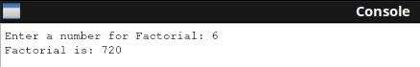

3. Declare a variable number initialized with value 7. Load it into a
register, add 5 to it, store the new value back into memory, and
print the updated value.

.data
number: .word 7
msg: .asciiz "Updated value in memory: "

.text
main:
lw $t0, number # Load 7
addi $t0, $t0, 5 # Add 5
sw $t0, number # Store 12 back to memory

li $v0, 4
la $a0, msg
syscall
li $v0, 1 # Print 12
move $a0, $t0
syscall

li $v0, 10
syscall

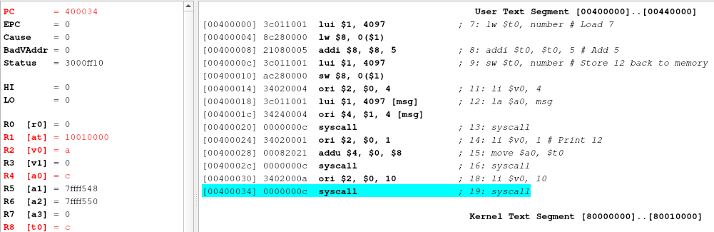
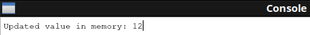

4. Declare a variable num = 4 and another variable square = 0.
5. Calculate the square of num (num × num), store the result in
square, and print it.
( 4 & 5 are in 1 program )

.data
num: .word 4
square: .word 0
msg: .asciiz "The square is: "

.text
main:
lw $t0, num
mul $t1, $t0, $t0 # 4 * 4
sw $t1, square # Store in memory

li $v0, 4
la $a0, msg
syscall
li $v0, 1
lw $a0, square # Print from memory
syscall

li $v0, 10
syscall

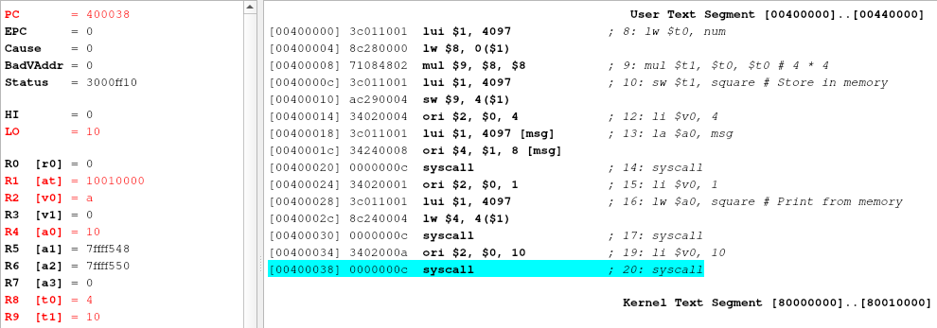
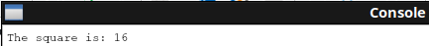

6. Write a MIPS program that asks the user for a number n, and
calculates the sum of numbers from 1 to n.

.data
prompt: .asciiz "Enter n: "
msg: .asciiz "Sum is: "

.text
main:
li $v0, 4
la $a0, prompt
syscall
li $v0, 5
syscall
move $t0, $v0 # $t0 = n

li $t1, 0 # sum = 0
li $t2, 1 # counter = 1
sum_loop:
bgt $t2, $t0, exit_sum
add $t1, $t1, $t2
addi $t2, $t2, 1
j sum_loop

exit_sum:
li $v0, 4
la $a0, msg
syscall
li $v0, 1
move $a0, $t1
syscall

li $v0, 10
syscall

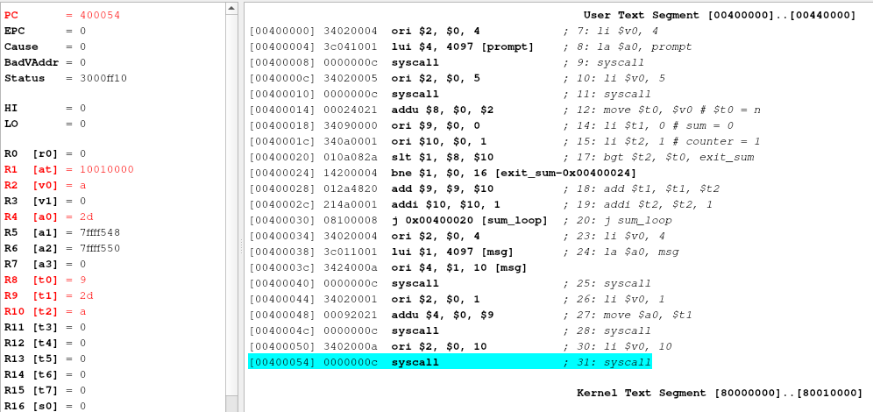
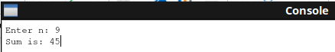

7. Write a MIPS program that takes two integers from the user and
prints which one is larger.

.data
msg: .asciiz "The larger number is: "

.text
main:
li $v0, 5 # Read int 1
syscall
move $t0, $v0
li $v0, 5 # Read int 2
syscall
move $t1, $v0

li $v0, 4
la $a0, msg
syscall

bgt $t0, $t1, first_bigger
move $a0, $t1 # $t1 is bigger
j print_res
first_bigger:
move $a0, $t0 # $t0 is bigger
print_res:
li $v0, 1
syscall

li $v0, 10
syscall

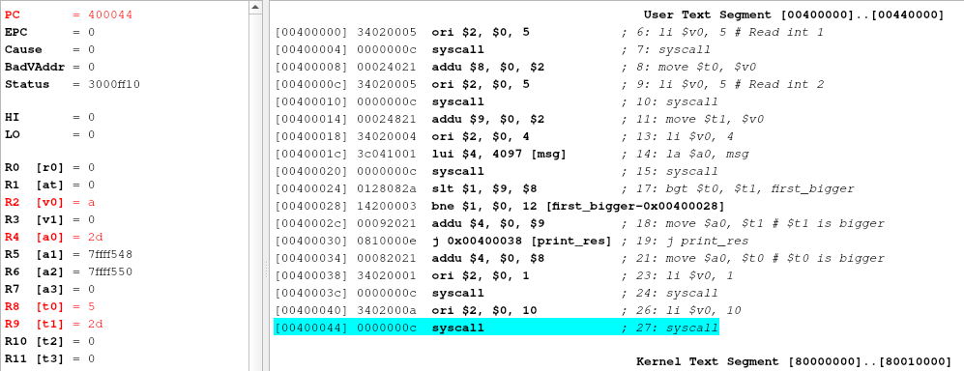
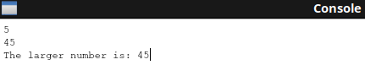

8. Write a program that reads a word from the user and prints it in
reverse order.

.data
str: .space 20
prompt: .asciiz "Enter word: "
res: .asciiz "Reversed: "

.text
main:
li $v0, 4 # Prompt
la $a0, prompt
syscall
li $v0, 8 # Read string
la $a0, str
li $a1, 20
syscall

li $v0, 4
la $a0, res
syscall

la $t0, str
find_end:
lb $t1, ($t0)
beq $t1, 10, start_rev # stop at newline
beq $t1, $zero, start_rev
addi $t0, $t0, 1
j find_end

start_rev:
addi $t0, $t0, -1
rev_loop:
la $t1, str
blt $t0, $t1, end_prog
li $v0, 11 # Print Char
lb $a0, ($t0)
syscall
addi $t0, $t0, -1
j rev_loop

end_prog:
li $v0, 10
syscall

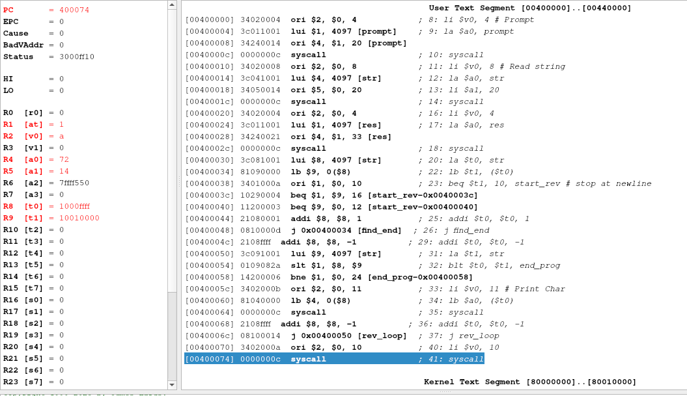

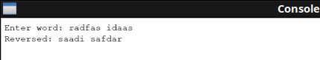

ASSIGNED TASKED IN MANUAL:
Example 1: Function Call (Addition)
main:
li $a0, 5 # load 5 in argument register a0
li $a1, 3 # load 3 in argument register a1
jal add_nums # call function (jump and link)
move $t0, $v0 # store result from v0 in t0
li $v0, 10 # exit
syscall
add_nums:
add $v0, $a0, $a1 # v0 = a0 + a1
jr $ra # return to address in ra

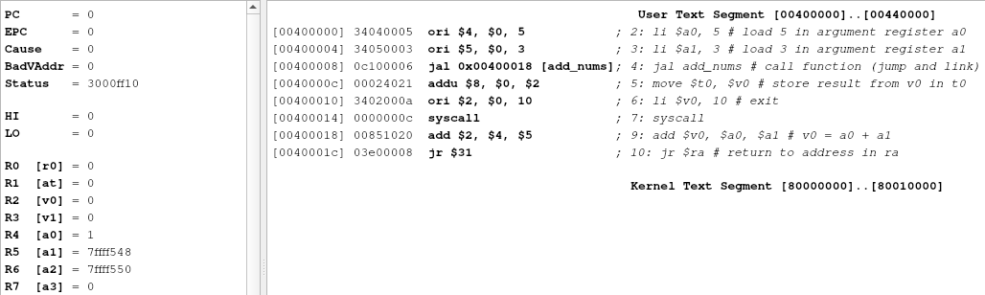
Example 2: Adding and Displaying a Sum
.data
msg: .asciiz "The sum is: " # Message to display
.text
.globl main
main:
# Load numbers into registers
li $t0, 5 # Load 5 into $t0
li $t1, 10 # Load 10 into $t1
# Add the numbers
add $t2, $t0, $t1 # $t2 = $t0 + $t1
# Print message
li $v0, 4 # Syscall code for print string
la $a0, msg # Load address of msg into $a0
syscall
# Print sum
li $v0, 1 # Syscall code for print integer
move $a0, $t2 # Move sum into $a0 for printing
syscall
# Exit program
li $v0, 10 # Syscall for exit
syscall
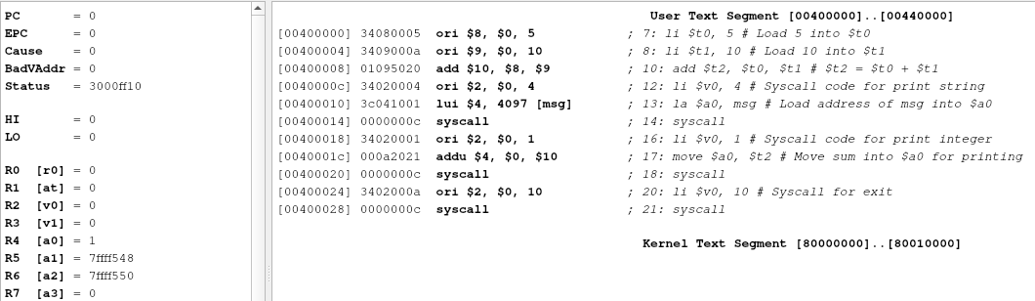
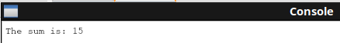
Example 3: Adding Two User Inputs
.data
prompt1: .asciiz "Enter first number: "
prompt2: .asciiz "Enter second number: "
resultMsg: .asciiz "The sum is: "
.text
.globl main
main:
# --- Ask for first number ---
li $v0, 4 # Print string syscall
la $a0, prompt1 # Load prompt1 message
syscall
li $v0, 5 # Read integer syscall
syscall
move $t0, $v0 # Store first number in $t0
# --- Ask for second number ---
li $v0, 4
la $a0, prompt2
syscall
li $v0, 5
syscall
move $t1, $v0 # Store second number in $t1
# --- Add the numbers ---
add $t2, $t0, $t1 # $t2 = $t0 + $t1
# --- Display the result ---
li $v0, 4 # Print "The sum is: "
la $a0, resultMsg
syscall
li $v0, 1 # Print integer syscall
move $a0, $t2 # Move sum into $a0
syscall
# --- Exit program ---
li $v0, 10 # Exit syscall
syscall

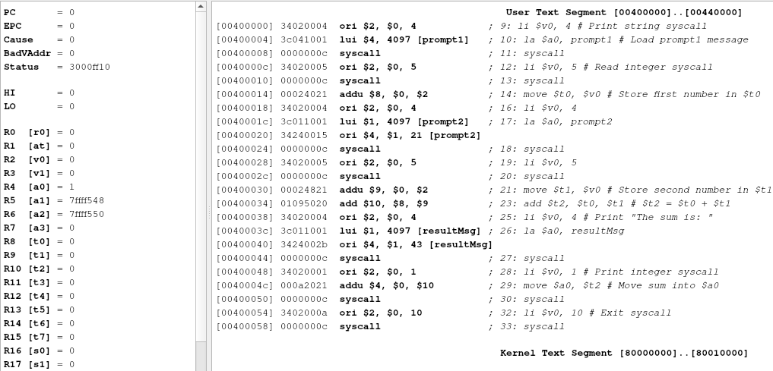
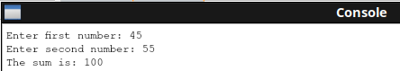

Example 4: Declaring Variables
.data
num1: .word 5 # integer variable with initial value 5
num2: .word 10 # another variable
result: .word 0 # variable to store result
.text
.globl main
main:
lw $t0, num1 # load num1 into register $t0
lw $t1, num2 # load num2 into register $t1
add $t2, $t0, $t1 # result = num1 + num2
sw $t2, result # store result back into memory
li $v0, 10 # exit program
syscall

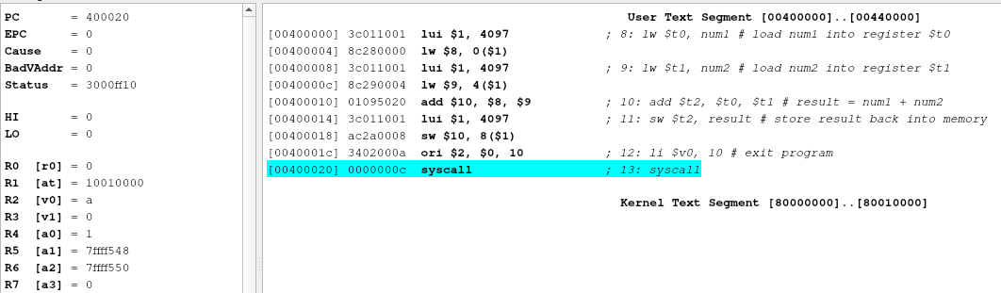

Q.1: Arithmetic Operations (Sum, Difference, Product)
.data
x:.word 25 # variable x = 25
y:.word 17 # variable y = 17
sum: .word 0 # to store x + y
diff:.word 0 # to store x - y
prod: .word 0 # to store x * y
msg1: .asciiz "Sum = "
msg2: .asciiz "\nDifference = "
msg3: .asciiz "\nProduct = "
.text
.globl main
main:
lw $t0, x # $t0 = x (25)
lw $t1, y # $t1 = y (17)
#--------------------------------
# Perform SUM
#--------------------------------
add $t2, $t0, $t1 # t2 = x + y
sw $t2, sum # store result in memory
# Print "Sum = "
li $v0, 4
la $a0, msg1
syscall
# Print sum value
li $v0, 1
lw $a0, sum
syscall
#--------------------------------
# Perform DIFFERENCE
#--------------------------------
sub $t3, $t0, $t1 # t3 = x - y
sw $t3, diff # store result
# Print "\nDifference = "
li $v0, 4
la $a0, msg2
syscall
# Print difference value
li $v0, 1
lw $a0, diff
syscall
#--------------------------------
# Perform PRODUCT
#--------------------------------
mul $t4, $t0, $t1 # t4 = x * y
sw $t4, prod # store result
# Print "\nProduct = "
li $v0, 4
la $a0, msg3
syscall
# Print product value
li $v0, 1
lw $a0, prod
syscall
# Exit program
li $v0, 10
syscall
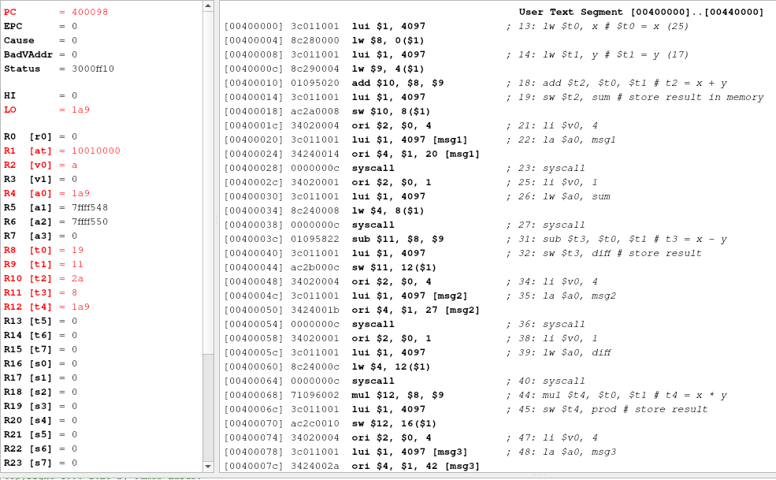
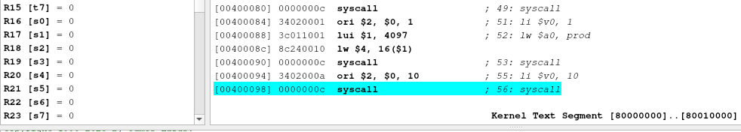
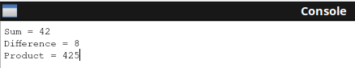

Q.2: Swapping Two Variables
.data
x: .word 10 # variable x = 10
y: .word 20 # variable y = 20
msg1: .asciiz "Before swapping:\n"
msg2: .asciiz "x = "
msg3: .asciiz "\ny = "
msg4: .asciiz "\n\nAfter swapping:\n"
.text
.globl main
main:
# Display before swapping
li $v0, 4
la $a0, msg1
syscall
li $v0, 4
la $a0, msg2
syscall
li $v0, 1
lw $a0, x
syscall
li $v0, 4
la $a0, msg3
syscall
li $v0, 1
lw $a0, y
syscall
# Load variables
lw $t0, x # $t0 = x (10)
lw $t1, y # $t1 = y (20)
# Swap using a temporary register $t2
move $t2, $t0 # t2 = x
move $t0, $t1 # t0 = y
move $t1, $t2 # t1 = x
# Store swapped values back to memory
sw $t0, x
sw $t1, y
# Display after swapping
li $v0, 4
la $a0, msg4
syscall
li $v0, 4
la $a0, msg2
syscall
li $v0, 1
lw $a0, x
syscall
li $v0, 4
la $a0, msg3
syscall
li $v0, 1
lw $a0, y
syscall
# Exit program
li $v0, 10
syscall
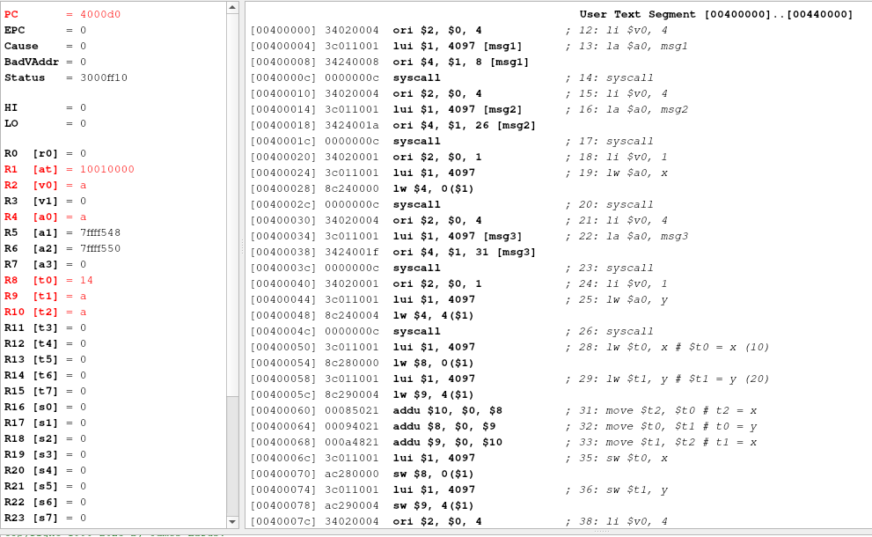
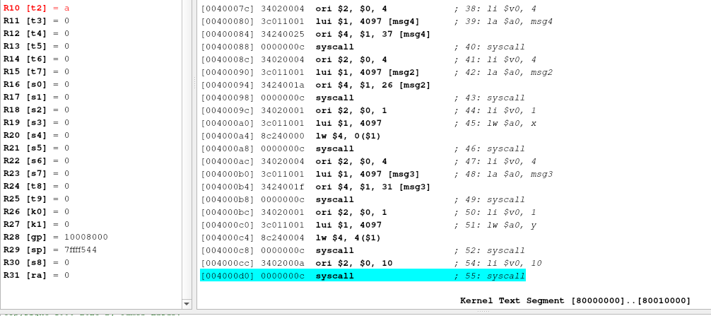

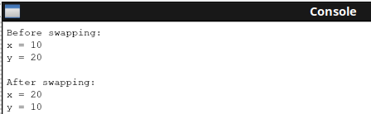

Factorial Program: Recursive

#==========================================
# Program: Recursive Factorial in MIPS
#==========================================
.data
prompt: .asciiz "Enter a number: "
resultMsg: .asciiz "Factorial is: "
.text
.globl main
main:
# Print prompt
li $v0, 4
la $a0, prompt
syscall
# Read integer input
li $v0, 5
syscall
move $a0, $v0 # $a0 = n (argument)
# Call factorial function
jal factorial
move $t0, $v0 # $v0 has result, move to $t0
# Print result message
li $v0, 4
la $a0, resultMsg
syscall
# Print factorial value
li $v0, 1
move $a0, $t0
syscall
# Exit
li $v0, 10
syscall
#------------------------------------------
# factorial function
# Input: $a0 = n
# Output: $v0 = factorial(n)
#------------------------------------------
factorial:
addi $sp, $sp, -8 # Make space on stack
sw $ra, 4($sp) # Save return address
sw $a0, 0($sp) # Save argument n
# Base case: if n <= 1, return 1
ble $a0, 1, base_case
# Recursive case: n * factorial(n-1)
addi $a0, $a0, -1 # n = n - 1
jal factorial # call factorial(n-1)
# On return, $v0 = factorial(n-1)
lw $a0, 0($sp) # restore n
mul $v0, $a0, $v0 # v0 = n * factorial(n-1)
j end_factorial
base_case:
li $v0, 1 # factorial(0 or 1) = 1
end_factorial:
lw $ra, 4($sp) # restore return address
addi $sp, $sp, 8 # free stack space
jr $ra # return to caller

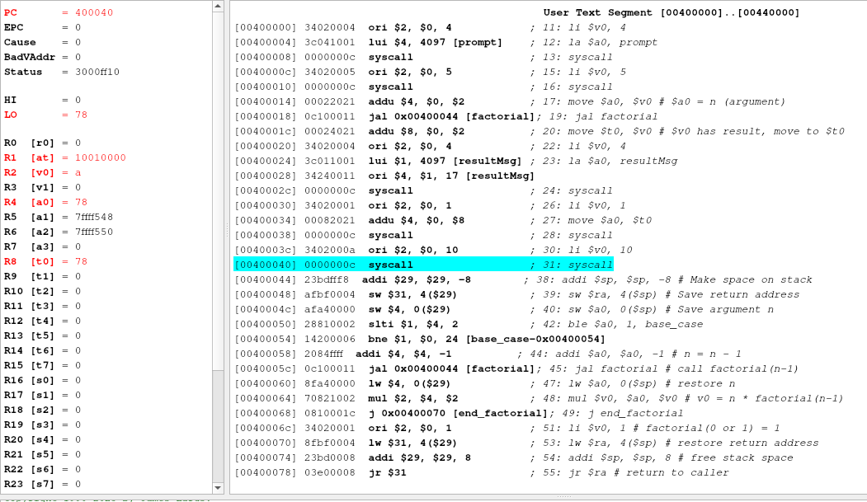
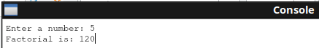

Q.1: Print All Array Elements
.data
numbers: .word 10, 20, 30, 40, 50 # array of 5 integers
size: .word 5 # number of elements
msg: .asciiz "Array elements:\n"
.text
main:
# print message
li $v0, 4 # syscall for print_string
la $a0, msg
syscall
la $t0, numbers # base address of array
lw $t1, size # number of elements now t1=5 (array length)
li $t2, 0 # set index register $t2 to 0. We'll use $t2 as the loop index
loop:
beq $t2, $t1, exit # branch if equal compare if index == size then exit
sll $t3, $t2, 2 # $t3 = $t2 << 2 → multiply index by 4 (because each word = 4 bytes).
add $t4, $t0, $t3 #add base address $t0 + offset $t3 → address of numbers[index] put into $t4.
lw $t5, 0($t4) # load numbers[index]
# print integer
li $v0, 1 # syscall for print_int
move $a0, $t5
syscall
# print a space
li $v0, 11 # syscall for print_char
li $a0, 32 # ASCII for space ' '
syscall
addi $t2, $t2, 1 # index++
j loop
exit:
li $v0, 10 # exit syscall
syscall

